**Grow Big  
A Progressive Web Application for Scaling Small business**



**Project Team**

|  |  |  |
| --- | --- | --- |
| **Sl. No.** | **Reg. No.** | **Student Name** |
| **1** | **17ETCS002001** | **A.Raaga Vardhini** |
| **2** | **17ETCS002004** | **Abhilash Ramu** |
| **3** | **17ETCS002007** | **Abhishek S** |
| **4** | **17ETCS002028** | **Anusha K S** |

**Supervisors: Prof. Kishor**

**March -2021**

**B. Tech. in Computer Science and Engineering**

**Faculty of ENGINEERING AND TECHNOLOGY**

**M. S. Ramaiah University of applied sciences**

**Bengaluru -560 054**

**Faculty of engineering and technology**



**Certificate**

*This is to certify that the Project titled “Development of Smart To- Do-List Application” is a bonafide work carried out in the Department of Computer Science and Engineering by <team member name:* ***Abhishek S*** *bearing Reg. No.****17ETCS002007*** *respectively in partial fulfilment of requirements for the award of B. Tech. Degree in Computer Science and Engineering of Ramaiah University of Applied Sciences.*

**March-2021**

**Prof. Kishor**

**Department of CSE**

**<HoD CSE Name> <Dean FET Name>**

**Professor and Head – Dept. of CSE Professor and Dean-FET**

**Faculty of engineering and technology**



**Certificate**

*This is to certify that the Project titled “Development of Smart To- Do-List Application” is a bonafide work carried out in the Department of Computer Science and Engineering by <team member name:* ***Abhilash Ramu*** *bearing Reg. No.****17ETCS002004*** *respectively in partial fulfilment of requirements for the award of B. Tech. Degree in Computer Science and Engineering of Ramaiah University of Applied Sciences.*

**March-2021**

**Prof. Kishor**

**Department of CSE**

**<HoD CSE Name> <Dean FET Name>**

**Professor and Head – Dept. of CSE Professor and Dean-FET**

**Faculty of engineering and technology**



**Certificate**

*This is to certify that the Project titled “Development of Smart To- Do-List Application” is a bonafide work carried out in the Department of Computer Science and Engineering by <team member names:* ***Anusha K S***  *bearing Reg. No.* ***17ETCS002001*** *respectively in partial fulfilment of requirements for the award of B. Tech. Degree in Computer Science and Engineering of Ramaiah University of Applied Sciences.*

**March-2021**

**Prof. Kishor**

**Department of CSE**

**<HoD CSE Name> <Dean FET Name>**

**Professor and Head – Dept. of CSE Professor and Dean-FET**

**Faculty of engineering and technology**



**Certificate**

*This is to certify that the Project titled “Development of Smart To- Do-List Application” is a bonafide work carried out in the Department of Computer Science and Engineering by <team member name :* ***A.RAAGA VARDHINI***  *bearing Reg. No.****17ETCS002001*** *respectively in partial fulfilment of requirements for the award of B. Tech. Degree in Computer Science and Engineering of Ramaiah University of Applied Sciences.*

**March-2021**

**Prof. Kishor**

**Department of CSE**

**<HoD CSE Name> <Dean FET Name>**

**Professor and Head – Dept. of CSE Professor and Dean-FET**

Declaration

*Development of Smart To- Do-List Application*

The project work is submitted in partial fulfilment of academic requirements for the award of B. Tech. Degree in the Department of Computer Science and Engineering of the Faculty of Engineering and Technology of Ramaiah University of Applied Sciences. The project report submitted herewith is a result of our own work and in conformance to the guidelines on plagiarism as laid out in the University Student Handbook. All sections of the text and results which have been obtained from other sources are fully referenced. We understand that cheating and plagiarism constitute a breach of University regulations, hence this project report has been passed through plagiarism check and the report has been submitted to the supervisor.

|  |  |  |  |
| --- | --- | --- | --- |
| **Sl. No.** | **Reg. No.** | **Student Name** | **Signature** |
| **1** | **17ETCS002001** | **A.Raaga Vardhini** |  |
| **2** | **17ETCS002004** | **Abhilash Ramu** |  |
| **3** | **17ETCS002007** | **Abhishek S** |  |
| **4** | **17ETCS002028** | **Anusha K S** |  |

**Date : June 2021**

# Acknowledgements

It is with extreme pleasure and pride that we present our B-Tech. dissertation titled “**Grow Big** A Progressive Web Application for Scaling Small business”. We would like to express our sincere thanks and gratitude to the following people, who stood by us throughout, helping us with much required inputs, guidance, knowledge and supported us.

We take great pleasure to express our sincere thanks and gratitude to academic project guide **Prof. Kishore.** Asst. Professor Department of CSE, for his support, guidance and suggestions throughout the project which is leading this project for the completion.

We express our sincere thanks to**, Dr. M. Arulanantham**, our respected Dean and to **Dr. Raghavendra Venkatesh Kulkarni,** Head of Department of Computer Science and Engineering, for their kind cooperation and support toward out dissertation, and to the management of Ramaiah University of Applied Science for their continued support. We are thankful to the staff members of the Computer Science and Engineering, RUAS for giving us good support and suggestion.

Lastly, we would like to thanks our parents and friends for their continued support, encouragement and motivation and God for paving our way of success in this object.

# Abstract

Progressive Web Apps are web apps that use emerging web browser APIs and features along with traditional progressive enhancement strategy to bring a native app-like user experience to cross-platform web applications. Progressive Web Apps are a useful design pattern, though they aren't a formalized standard. Since online Supermarket Grocery Supplies has become an integral part of modern society . Grocery shopping is the time consuming and tedious job to do.

To make grocery shopping a bit convenient and easier, so we have worked on it which ensure timely delivery of groceries and higher money saving benefits and help small business which acts as link for B2C.

**SCOPE:**

Develop A Full Stack Progressive Web Application to connecting all small businesses at one place.

**Table of Contents**

Acknowledgements ii

Abstract iii

List of Figures vii

List of Tables ix

1. Introduction 1

1.1 Introduction 1

1.2 Literature Survey 2

1.3 Conclusion 3

2. Background Theory 4

2.1 Background Theory: 4

2.1.1 HTML 4

2.1.2 CSS 4

2.1.3 JavaScript 5

2.1.4 Bootsrap 5

2.1.5 Node.js 6

2.1.6 EJS 6

2.1.7 Express…………………………………………………………………7

2.1.8 MongoDB DataBae………………………………………………………………………………………..8

2.2 Merits & Demerits 7

2.2.1 Merits………………………………………………………………………………………………………………8

2.2.2 Demerits………………………………………………………………………………………………………….9

2.3 Conclusion 9

3. Aim and Objectives 10

3.1 Title 10

3.2 Aim 10

3.3 Objectives 10

3.4 Functional Requirements 11

3.5 Method and Methodology 11

3.6 Conclusion 13

4. Problem Solving 14

4.1 Design 14

4.1.1 Use Case Diagram 14

4.1.2 Sequence Diagrams 16

4.1.3: Archtectural Design…………………………………………………16

4.1.4. Flow Chart…………………………………………………………..17

4.2 Implementation 26

4.3 Testing 42

4.4 Performance Analysis 43

4.1.1 Battery consumption 43

4.1.2 Response time 57

5. Results 61

5.1 Resulsts 61

5.1.1 61

5.1.2 62

5.1.3 63

5.1.4 64

5.1.5 65

5.1.6 66

5.1.7 67

5.1.8 68

5.2 Summary 68

6. Project Costing 69

6.1 Project Cost Estimation 69

6.2 Conclusion 69

7. Conclusions and Suggestions for Future Work 70

7.1 Conclusion 70

7.2 Suggestion for future work 71

References 72

Appendix 73

# 1. Introduction

In this chapter, the project is introduced with its theme followed by its purpose. Then a literature survey is documented stating most popular existing applications under domain of current project and their key features. In the end, current project and its output will be compared with the existing application and in the end, key features of current project will be evaluated.

## Introduction

Since online Supermarket Grocery Supplies has become an integral part of modern society An online grocer is either a [brick-and-mortar](https://en.wikipedia.org/wiki/Brick_and_mortar) [supermarket](https://en.wikipedia.org/wiki/Supermarket) or [grocery store](https://en.wikipedia.org/wiki/Grocery_store) that allows online ordering, or a standalone [e-commerce](https://en.wikipedia.org/wiki/E-commerce) service that includes grocery items. There is usually a delivery charge for this service.

Since it is a business scaling application all the store can register here in one place so users can select stores and order or shops from their known nearby stores.

To make items and groceries shopping a bit convenient and easier, so we are working on it which ensure timely delivery of groceries and higher money saving benefits and help small business. Maintenance of the quality of the item and satisfy the customer requirements. Delivering product on time. Increased chances to surf things customer want as there are multiple stores at a single location. To provide transparency in purchasing items from where the goods being delivered and increased cost opportunity as grocery is being delivered from nearby stores.

In this project the aim is To Develop A Full Stack Progressive Web Application to connecting all small businesses at one place. A progressive web application is a type of application software delivered through the web, built using common web technologies including HTML, CSS,JavaScript. It is intended to work on any platform that uses a standards-compliant browser, including both desktop and mobile devices

## 1.2 Literature Survey

Below is the tabulated study of Papers available on this domain. The results are as follows.

Table 1 Literature Survey

|  |  |  |  |  |  |  |  |
| --- | --- | --- | --- | --- | --- | --- | --- |
| **S**  **l**  **N**  **o.** | **Author(s)** | **Journal Name and year of publication** | **Research Focus** | **Findings in Research** | **Conclusions derived via authors** | **Limitations in the Study** | **Conclusion of Published Work** |
| 1 | Khan.A.Badi | “Progressive Web Application Assessment Using AHP,” | On developing progressive web application | Could find the procedure to proceed with taking on PWA once backend was  completed | It increases conversion,security and simplicity. | Not much focused on assessment than implementation | PWA helps us in getting things faster than regular websites and is economically feasible |
| 2 | **Steve Hansen and Athula Ginige** | **Web Engineering*: A New Discipline for Development of Web-based Systems*** | On how WEB based sytems have paved way for ecommerce sites | It helps us in knowing pros of developing web based systems and how the dynamics helps connect people | Web engineering is the key for the future prospects of IT industry | Lack of elaboration of future prsospects of web engineering | How web engineering helps in analaysing dynamics of web based systems and continuously changing to cater the needs of customer |

## 1.3 Conclusion

In this chapter, explained about Progressive web applications.We aim to develop Full stack Progressive web application to connecting all small businesses at one place. A progressive web application is a type of application software delivered through the web, built using common web technologies including HTML, CSS,NodeJs and EJS along with the support of MongoDB. It is intended to work on any platform that uses a standards-compliant browser, including both desktop and mobile devices. Above explained details of literature survey of Project.

# 2. Background Theory

In this chapter, all theory related to proposed project including technical aspect and resources are explained. This section starts with discussion of Programming Languages and Framework Used, IDE’s on which the proposed project is built.

## 2.1 Background Theory:

This section gives complete knowledge and understanding of different technologies and framework that were required in this project for its completion. The background Theory is listed below**:**

**FRONT-END:**

### 2.1.1 HTML

**HTML** is an acronym which stands for Hyper Text Markup Language which is used for creating web pages and web applications. We have have used this framework to give consistent structure and to abstract differences between browsers.

### 2.1.2 CSS

**Cascading Style Sheets**, fondly referred to as CSS, is a simple design language intended to simplify the process of making web pages presentable.

CSS along with bootstrap framework helped us in positioning our web elements and styling it to the present form with attractive colours, layouts and fonts.

**2.1.3: BOOTSTRAP**

**Responsible of BACK-END:**

### 2.1.5 Node.js

## Node.js is an exciting new platform for developing web applications, application servers, any sort of network server or client, and general-purpose programming. It is designed for extreme scalability in networked applications through an ingenious combination of server-side JavaScript, asynchronous I/O, and asynchronous programming.

Along with the framework of Express JS which is used as template by Node JS and helps in embedding javascripts to HTML which helped us in creating “View” folders which visually represents dynamic content to page which are hidden behind and supports server side rendering.

### 

### 2.1.6 EJS

Express provides a minimal interface to build our applications. It provides us the tools that are required to build our app. It is flexible as there are numerous modules available on **npm**, which can be directly plugged into Express.

Unlike its competitors like Rails and Django, which have an opinionated way of building applications, Express has no "best way" to do something. It is very flexible and pluggable.

It helps in parsing of event based contents in an order.

### 

### 2.1.7 Express

Express.js is a Node js web application server framework, which is specifically designed for building single-page, multi-page, and hybrid web applications.

## Express JS simplifies the process by providing effective route creation and support for middlewares. It gives you all the tools you will need for route creation,  parse payloads, create HTML view pages, work with middleware functions and connect to databases.

### 2.1.8 MongoDB Database

MongoDB is a cross-platform, document oriented database that provides, high performance, high availability, and easy scalability. MongoDB works on concept of collection and document. MongoDB is a cross-platform, document oriented database that provides, high performance, high availability, and easy scalability. MongoDB works on concept of collection and document.

Any relational database has a typical schema design that shows number of tables and the relationship between these tables. While in MongoDB, there is no concept of relationship.

**Advantages of MongoDB database:**

* **Schema less** − MongoDB is a document database in which one collection holds different documents. Number of fields, content and size of the document can differ from one document to another.
* **Ease of scale-out** − MongoDB is easy to scale.

## 

## 2.2 Merits and Demerits:

**2.2.1: Merits**

1.PWA are deployed inb mobile phones and are fast,engaging and user friendly

2.It is much cheaper than developing mobile applications and is platform independent.

3.PWA can be accessed **with low internet connection and consumes less data**

4. With PWA, there are no such restrictions as you are in charge of the entire process. It eliminates all the process of visiting web store for app installation saving both time and data. You can directly download the PWA to tour home screen.

**5.** The major requirement of a website to be called a progressive web app is that it must be secured by HTTPS. Enabling HTTPS provides data safety and reduces the risk of security issues or data tampering.

6. Our e-commerce site delivery is faster as orders are delivered within city.

7.Directly connects buyer with consumer leading to transparency

8.helps small business to connect to wider customers and helps display their shop details and items in our website.

9.Users has access to wider range of items to book from various shops and get it delivered in the same day or few hours from placing order.

10.Saves time of consumers and good rating helps business to expand their credibility.

**2.2.2: Demerits:**

1. Progressive Web Apps eliminates the need of visiting an app store for downloading the app which in turn saves the time and internet data of the users. But on the downside, it also affects the traffic which normal applications gets from an app store, therefore, causing significant traffic loss.
2. Despite so much progress made in this technology, still, there are certain limitations of using progressive web apps on iOS. As of now, not all the features that work on Android devices are available for iOS devices such as push notifications and the shortcut for the home screen.
3. Lack of privacy is a serious disadvantage of e-commerce. A customer has to provide his personal details before making a purchase like address, name, and phone number and so on
4. An e-commerce site is heavily dependent on its website. If it is not properly projected or the software is not implemented the site can face technology hiccups. It then comes under the serious radar.

## 2.3 Conclusion:

In this Chapter, All background knowledge for completion of this project are explained elaborately. Also, in each mentioned resource and technology, the reason for its use is also expressed. Languages like HTML, CSS, Bootsrap, Node js, EJS, MongoDB database and its use in this project is explained. And in the explained the advantages of using MongoDB Database.

In the end, above explained about Merits and Demerits of this Project.

# 3. Aim and Objectives

This chapter focuses on defined title and Aim of the project correctly and clearly. Later this chapter also includes the required objectives that needed to be fulfilled in order to complete this project. Functional Requirements are well documented in this section since it is required to design different diagrams leading to complete view of the project. This is followed by method and methodologies that tabulates the procedure at will be followed in order to complete the objectives. This section then ends with a summary.

## 3.1 Title:

**Grow Big** A Progressive Web Application

## 3.2 Aim:

## To Develop A Full Stack Progressive Web Application for Scaling Small business.

## 3.3 Objectives

The objectives of the proposed Project are listed below:

1. To conduct literature survey on scaling business systems
2. To analyze survey and collect requirements.
3. To Design & develop front-end user interface based on requirements
4. To Implement server side work develop Back-end to provide data to clients.
5. To develop PWA: Progressive Web Application for installation purpose.
6. To test developed application on local system.
7. To host live using appropriate service for usage purpose
8. Study its Performance and write report.

## 3.4 Functional Requirements

The functional Requirements for this project are mentioned below:

FR 1:

## 3.5 Method and Methodology

Table 2 Methods and Methodology

|  |  |  |  |
| --- | --- | --- | --- |
| **Objective No.** | **Statement of the Objective** | **Method/ Methodology** | **Resources Utilised** |
| 1 | To conduct literature survey on scaling business | 1.1: Conducted literature survey based on our business scaling application by referring some of existing application.  1.2: There are many grocery & Items ordering systems but not helpful for all small businesses and we want to help them to grow with us | . I. Khan, A. Al-Badi, and M. Al-Kindi, “Progressive Web Application Assessment Using AHP,” Procedia Comput. Sci., vol. 155, pp. 289–294, 2019. |
| 2 | To analyse survey and collect requirements | 2.1: Based on information gathered and as per our application need requirements are collected.  2.2: User should be able to create account for their store and login.  2.3: System should show all the registered stores in home page.  2.4: Customer should be able to search stores and be able to order from their known surroundings particular store. | <https://wikibrand.blogspot.com/2012/12/week-2-cart-page-and-registration-page.html> |
| 3 | To Design & develop front-end user interface based on requirements | 3.1: As per requirements, need to develop front-end using appropriate technologies.  3.2: HTML,CSS for front-end portion and adding styles and javascript scripting language to make the site interactive for the user and to add useful functionalities.  3.3: Bootstrap to add inbuilt CSS components and styles. It also contains come basic components that we can directly use by copying code. | https://www.freecodecamp.org/news/what-is-front-end-development/ |
| 4 | To Implement server side work develop Back-end to provide data to clients. | 4.1: To store data, give back to client on user interface and carry necessary work and calculation on server side have to -choose appropriate back-end tools and frameworks.  4.2: Node.js helps to write javascript and run on server side.  4.3:Express.js is a Node js web application server framework, It has become the standard server framework for node.js. Express is the backend part.  4.4: MongoDB The standard NoSQL database for flexibility and ease of usage. | http://thinkapps.com/blog/development/basics-back-end-development/ |
| 5 | To develop PWA: Progressive Web Application for installation purpose. | 5.1: Progressive Web Application which can be installed directly from browser and works same as native apps. | https://developers.google.com/web/ilt/pwa/ |
| 6 | To test developed application on local system. | 6.1: After development testing on local host by trying to access all the features and testing of database access.  6.2: Try to search stores and try to login and signup and checking the database that we are able to maintain proper user data. |  |
| 7 | To host live using appropriate service for usage purpose | 7.1: Purchase domain and hosting live website by choosing appropriate services.  7.2: Host the live website for use. |  |
| 8 | Study its performance and write report. | 8.1: According to Performance write a report. | https://in.godaddy.com/domains#:~:text=%20How%20do%20I%20buy%20a%20domain%20name%3F,own%20domain.%20As%20long%20as%20it%27s...%20More%20 |

## 

## 3.6 Conclusion:

## 

This particular chapter focused on defined title and Aim of the project correctly. Later this chapter included required objectives that were required to be fulfilled to complete this project. Functional Requirements is documented successfully in this section followed by method and methodologies which is successfully tabulated in order to know the steps used in completing the objectives including resources used.

# 

# 4. Problem Solving

In this section, the actual dissection of project is done and each module is built piece by piece in order to complete the project. In design section, the application has been built in accordance with functional requirements based on which diagrams like Use Case and Low Level Sequence Diagram is drawn. In implementation section, snips of important code is displayed with their explanation given below. In testing section, all functional requirements are tested and the result is analysed resulting in status of test condition. In the ending section, performance analysis is done on various factors such as battery, booting time and time requirement for major operation.

## 4.1 Design

Design is necessary when it comes to development since it acts as a blueprint for entire process from requirement making to finished (final product). Hence, in this section designs specific to this project like use case, sequence diagram etc. are attached.

### 4.1.1 Use Case Diagram

**4.1.2: Sequential Diagram**

**4.1.3: Archtectural Design**

**4.1.4: Flow Chart:**

## 4.2 Implementation

Creating user collection and mongoose model:

Creating login/signup page:

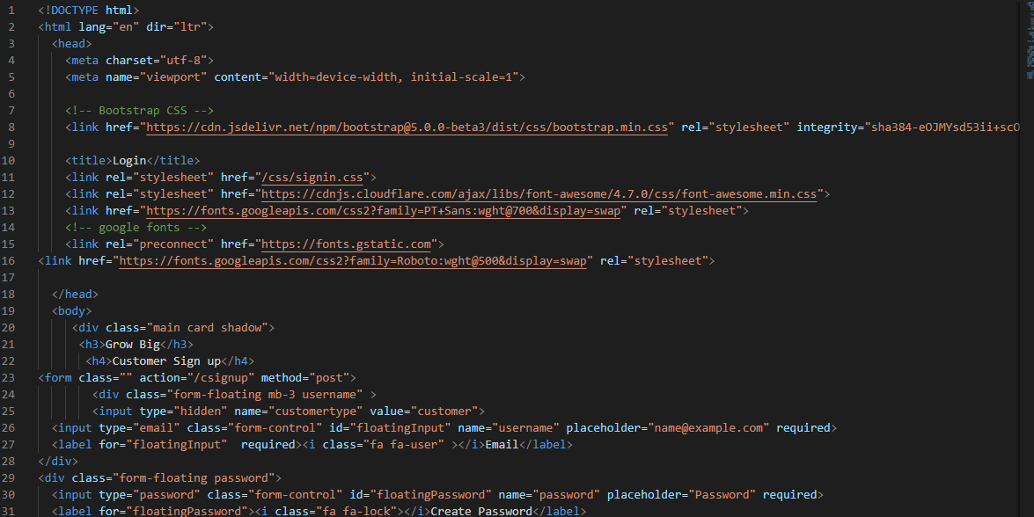

Result:

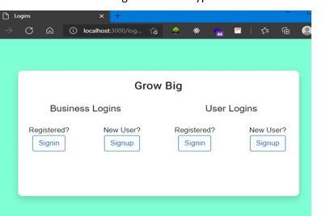

Different signup page for business user and customer:

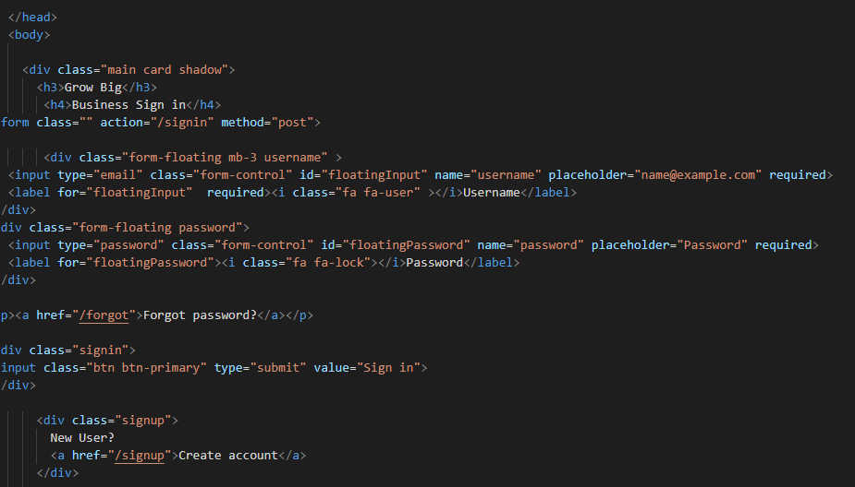

Results:

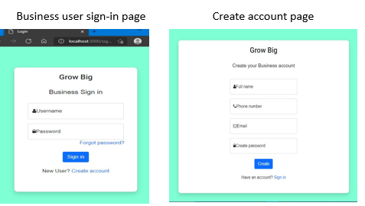

Creating Home page:

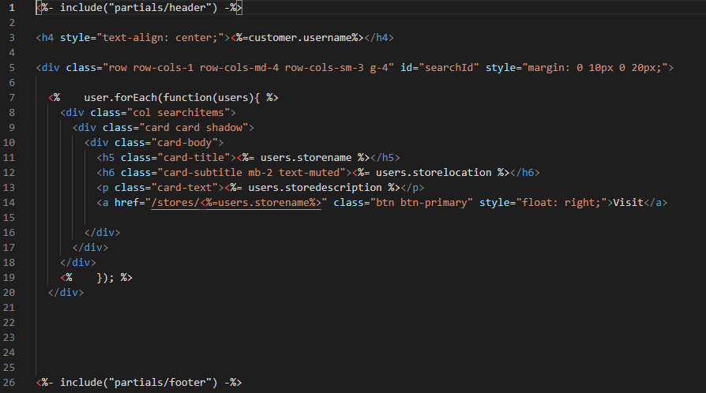

Results:

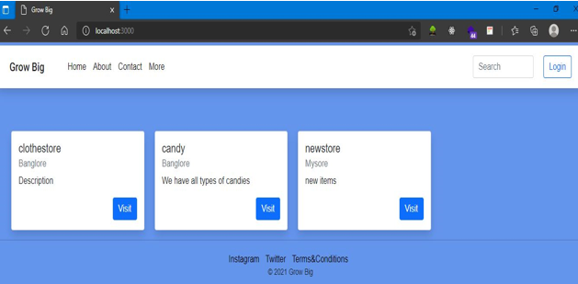

Updating Store:

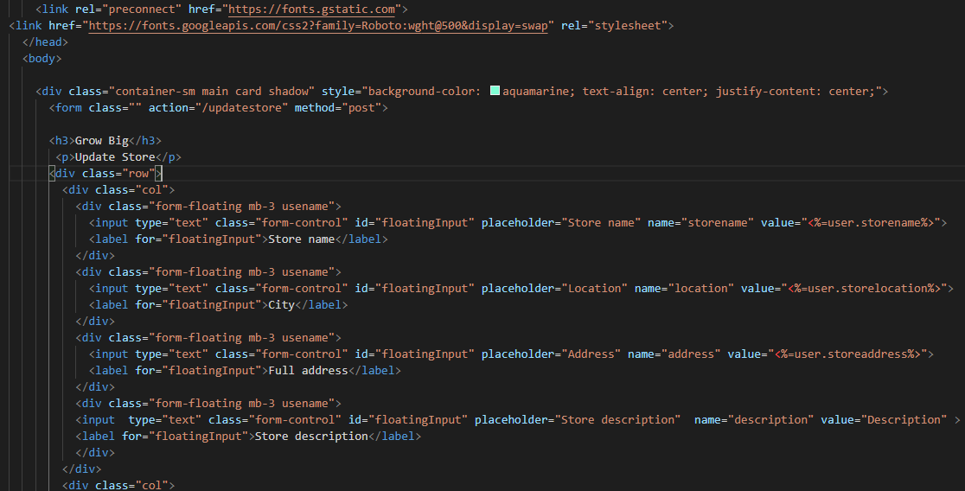

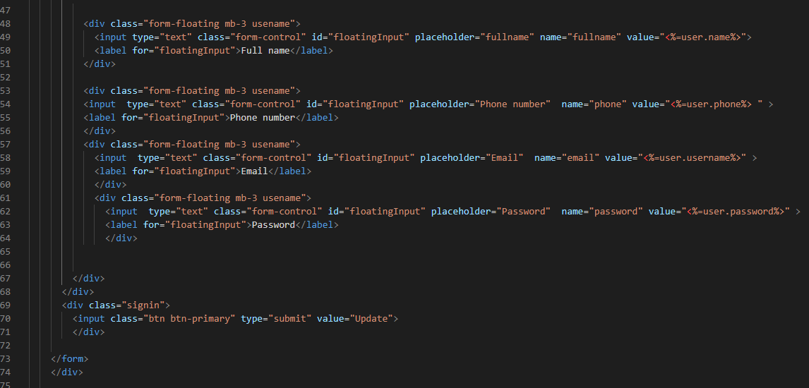

RESULTS:

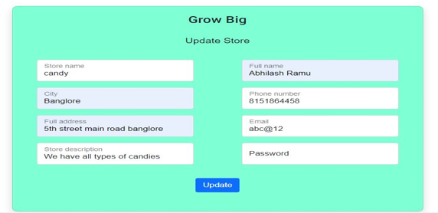

Items ordered by customers:

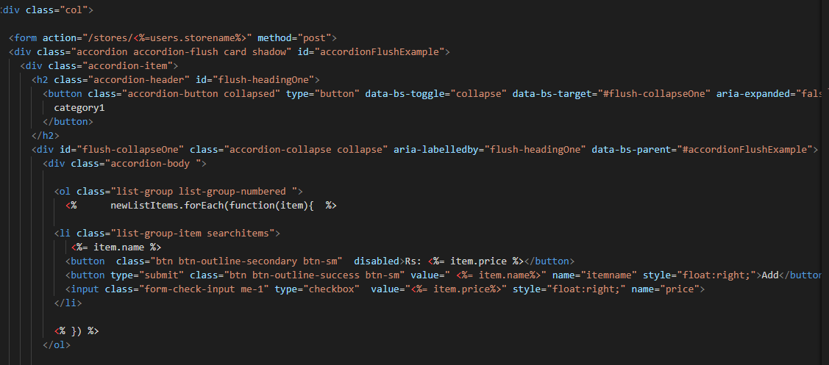

RESULTS:

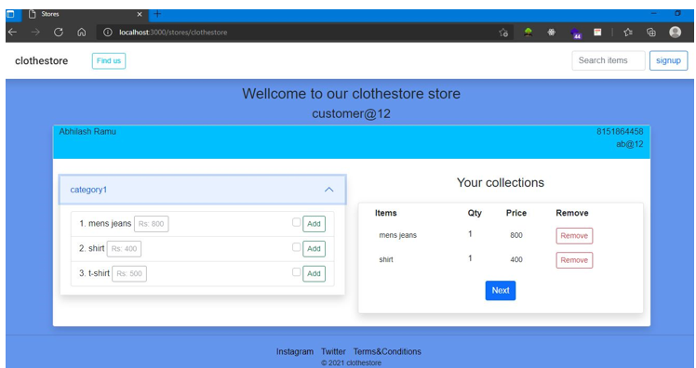

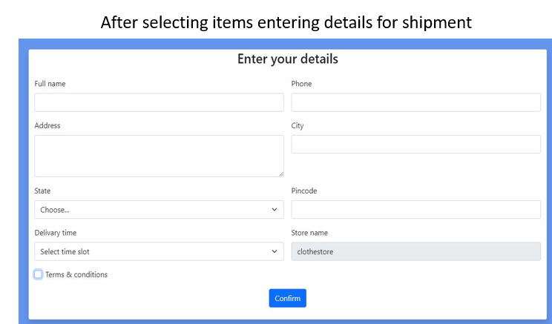

Searching for particular location/stores:

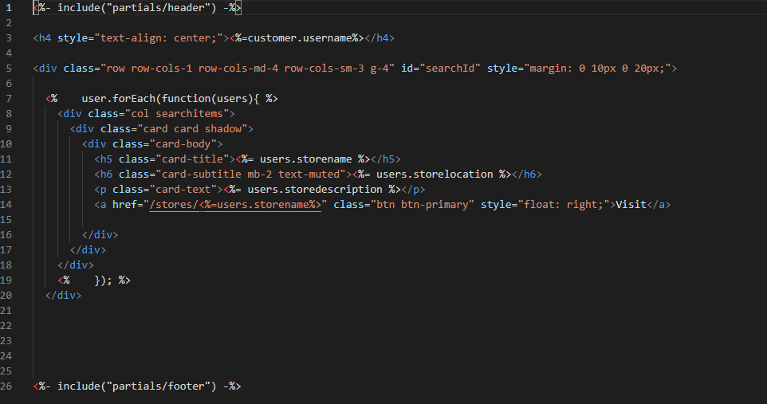

RESULTS:

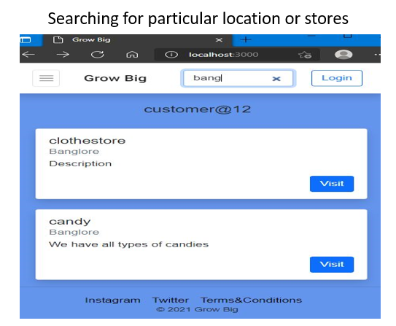

Database:

Differentiating users and customers where both comes under collection, with the help of user interface of mongodb databse in robo3t application

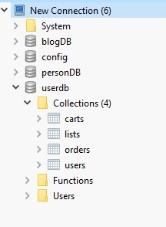

Now we have created tables called collections with the database name userdb and ordering by their names

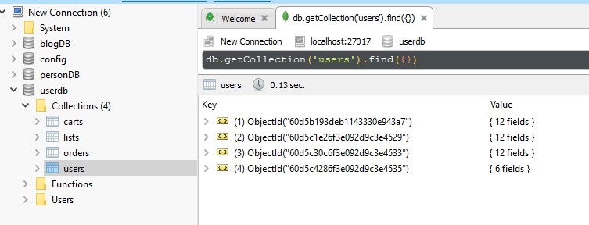

Here user is business user and password is hashed:

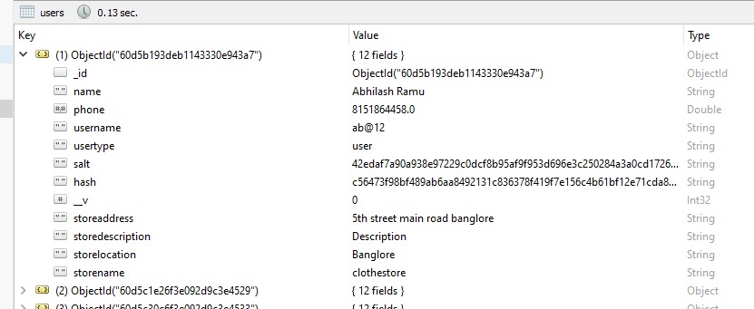

# 6. Project Costing

This chapter deals with costing of this project which gives an overall estimation of expenses that was required to complete this project. This Covers expenses of testing devices, Platform and Hardware cost, Human Resource Cost and a grand total of Entire cost.

## 6.1 Project Cost Estimation

The cost of project is summarised in a tabular form displayed below:

Table 5 Cost estimation table

|  |  |  |
| --- | --- | --- |
| **Serial Number** | **Resources and Work** | **Cost(Rs)** |
| 1 | Web Hosting | 2400/yr |
| 2 | Domain Purchase | 800/yr |
| 3 | Human Resources (4 * /-) |  |
|  | **TOTAL** |  |

## 6.2 Summary

Since this project didn’t have any physical model, hence no expenses were made for physical model. However, effort on making the software via parallel learning of new technology raised the Human Resource cost which can be seen in Table 5.

# 7. Conclusions and Suggestions for Future Work

In this chapter, conclusion has been given for entire project along with conclusion to each section present in the report. All are explained with status of completion of each section mentioned clearly. This section ends with Suggestion and scope of future work which direct this project towards new openings of technology where the same project can be extended in order to meet the requirement of customers time to time.

## 7.1 Conclusion

This project started with Literature survey done via gathering information from patented documents and reputed Websites. Books from Orally publication were also used as a guide. Also, popular application were listed against their features making it clearer to compare and contrast applications with each other along with application proposed in this project. Background Theory of all resources including technology used, Framework selected, IDE’s worked upon and engines applied were extensively elaborated so that these theory can be applied effectively and the reason for their use application can be well understood. Later, all objectives were listed done after declaring title and Aim of the project and methods and mythologies in order to complete the bulleted objectives were well tabulated. From objectives, Functional Requirement was extracted and were well segregated for sequential completion of project. Later, diagrams including Use-case, Sequence, Class, Block and Widget Hierarchy Diagram were created giving complete view of the project from different perspective. Implementation of the project was displayed via displaying code written in both java and Dart programming language interacting with each other to create the application. Testing was done for all functionalities and were found to be working successfully. Later in result section, all screenshot of application in different states were taken in order to demonstrate the end product of this project. Each screenshot was explained with its importance as a view for the application. Performance analysis was done in order to give numerical value to performance of the application clearly stating the advancement in application proposed in this project compared to other applications present in the market. Later project cost estimation was done in order to know the financial asset required to rebuild this project. The entire project was concluded with suitable conclusion and its scope in near future.

## 7.2 Suggestion for future work:

To add more functionalities in the future and design system much better than what is being done till now and developing an android application in place of PWA to reach larger section of people.

# References

* **Binayak Panda , Pradeepta Kumar Panigrahi,2012 , April .A Model for Small Scale Website Development Gandhi Institute of Engineering & Technology ,Gunupur ,Orissa ,India*. IJCST Vol.3,Issue 2,April –June 2012***
* **Chai Lee Goi,“The impact of website development on organisation performance: Malaysia’s perspective”, *African Journal of Business Management Vol. 6(7), 22, pp. 2435-2448, 2012.***
* **San Murugesan, Yogesh Deshpande, Steve Hansen and Athula Ginige,“Web Engineering*: A New Discipline for Development of Web-based Systems”,WebISM (Web-based Information Systems and Methodologies) Research Group, Campbelltown, Australia.***